# SPICT, CMSY and BSM: Data, Priors and Assumptions

## CMSY – Information and Priors Required

### r

Defined at the outset. Set at High (0.6-1.5), Medium (0.2-0.8), Low (0.05-0.5) or Very Low (0.015-0.1). Alternatively, the range can be set manually.

### Initial Biomass Range

Can be defined with a range, High (0.5-0.9), Medium (0.2-0.6) and Low (0.01-0.4). If not defined then the default rules are that if the time series starts before 1960, the stock is assumed to have high initial biomass! In all other cases, medium initial biomass is assumed!

### Final Biomass Range

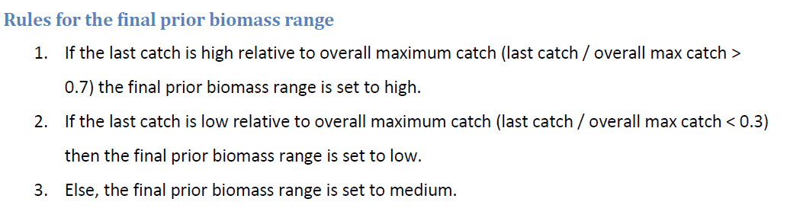

### Intermediate Biomass Range

Sets a year and a biomass range within the time series, either manually or by default. The default settings look at the contrast in catches, or the timing of the minimum and max catches. More details in the paper supplemental material.

### k

Different rules depending on the starting biomass of the stock. If the mean of the range for the end biomass is less than 0.5 then (low biomass stock):

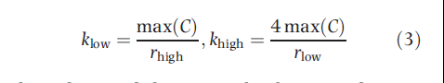

Or for high biomass stock (>0.5):

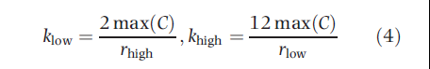

### q

Rules for the range derived from simulations.

If the mean of the end biomass range is higher than 0.5 (high biomass stock) then the lower q range is:



Where rpgm is the geometric mean of the r prior range, and the CPUEmean and Cmean are over the last 5 years of catch and CPUE time series for medium and high resilience stocks, but over 10 years for lower resilience stocks.

The upper range is:



For low biomass stocks, the equations are the same but instead of using 0.25 and 0.5, the multipliers are 0.5 and 1.0.

## BSM – Information and Priors required

This CMSY-BSM method uses the same basic information as CMSY but can also incorporate an abundance index (unfortunately it can’t use multiple, unlike SPICT). The priors are input the same way as for CMSY, but it then converts them to single values and s.d.

### log.r

Takes the mean of the r range.

log.r = log ((r.low + r.high)/2)

### log.r.sd

Defined in paper as:



And in the code as:

log.r.sd = abs ((log.r - log(r.low))/2)

### Biomass Ranges

These are used to define the priors for k and q, but not used directly.

### log.k

Uses the k.low and k.hi as derived for CMSY and then takes the mean of the k range.

log.k = log ((k.low + k.high)/2)

The s.d. of the normal distribution in log-space was assumed to be a quarter of the distance between the central value and the lower bound of the k range.

log.k.sd = (log.k - log(k.low))/4

Not sure quite how BSM uses the k prior, as it seems to use it as a starting point for the search (starting at 20% of the range).

### log.q

Uses the q.low and q.hi as derived for CMSY and then takes the mean of the q range.

log.q = log ((q.low + q.high)/2)

The s.d. of the normal distribution in log-space was assumed to be a quarter of the distance between the central value and the lower bound of the q range.

log.q.sd = (log.q - log(q.low))/4

## SPICT

We can set priors for r, q and k that are the same as are being fed into the CMSY-BSM model, which should be a fair comparison between the two.

CMSY is fundamentally different in how it uses the prior information, so will never be a perfect comparison, but maybe that is ok.

SPICT can however use multiple abundance indices, unlike BSM, so should we restrict ourselves to just using one? There is only one for most stocks, so it’s not really an issue most of the time.